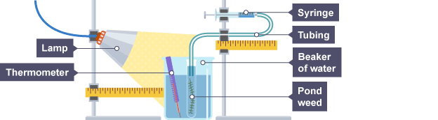
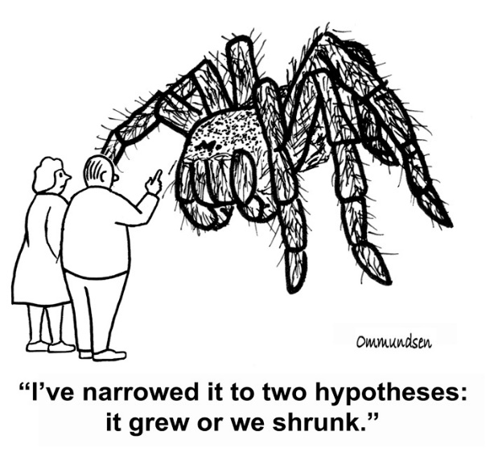
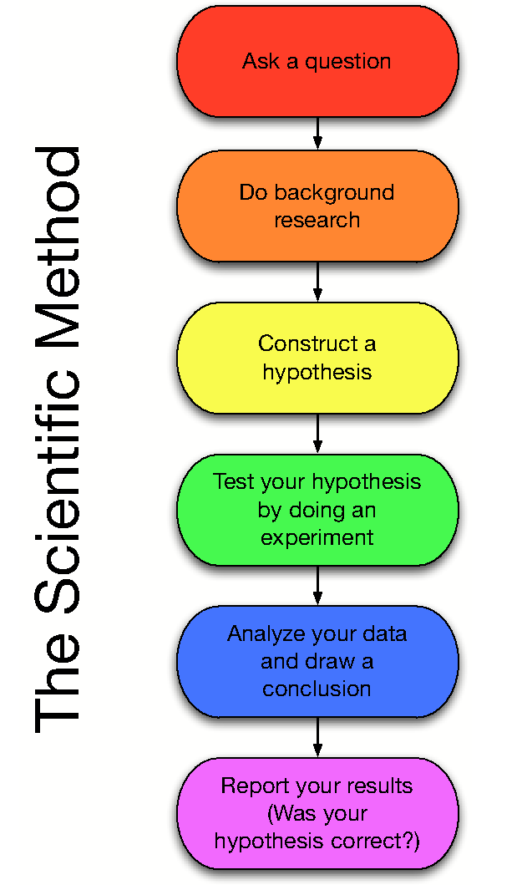
Eochar Fhocail- An Modh Eolaíochta:
- Hipitéis- buille faoi thuairim oideachasúil
- Turgnamh- obair phraiticiúil leagtha síos chun do hipitéis a tástáil
- Breathnóireacht- analís ar an sonraí (data)
- Conclúd- Miniú ar na freagraí faighte agat.
- Fionnachtain (discovery)-
- Teoiric (theory)- Hipitéis atá cruthaithe (freagra is féarr)
m.s. Teoiric na hÉabhlóide.
7. Dlí/Prionsabal- Hipitéis atá 100% cruthaithe
m.s. Dlí Hooke
----------------------------------------------
- Athróg (Variable)= an factóir atá á athrú agat i rith turgnamh
m.s. fiosriúchán ar an teocht is féarr le ‘Pondweed’. Déan é a thástáil ag 10⁰C, 30⁰C & 50⁰C. Sé an athróg ná an ___________ anseo.
- Tairiseach/Seasmhach (Constant)= factóir a fhanann mar an gcéánna I rith do thurgamh.
m.s. fad ón tsolas & déine solas (bolgán 40W) don Pondweed.

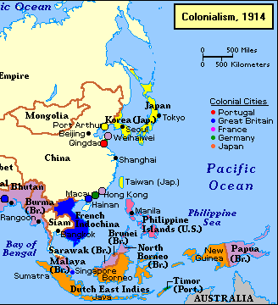
Cleactadh ar ár fhoclóireacht don Modh Eolaíochta.

- An cáis aisteach do BeriBeri
Bhí galar aisteach néarógach ag déanamh ionfabhtú ar muintir na Dutch East Indies i 1887. Beri Beri ab ainm don galar seo. Bhí na siomptam seo a leanas i láthar- cailteanas easpa goile (loss of appetite), laige mhatáinach agus bhí go leoir daoine ag fáil bhás de bharr cliseadh croí (heart failure).
Do cheap na n-eolaithe b’iad baictéir ba chúis leis an BeriBeri.
Thugadar instealladh do na bhaicteir ó fhuil na n-othair le BeriBeri go dtí sicíní. Thugadar faoin ndeara go fhuair na sicíní seo tinn. Ach fuair na sicíní ná bhfuair an instealladh tinn fresin!
Thug Dr. Eijkman, duine don ghrúpa, seo a leanas faoi ndeara:
Roimh an turgnamh bhí an bia réimse céanna ag gach sicín- bhí rís donn á ithe acu. I rith an turgnamh bhí rís bán (polished white rice) á n-ithe acu. Rinne Dr. Eijkman roinnt taighde & fuair sé amach nach raibh aon thiamine (vitimín) i rís bhán & tá an vitamín seo riachtanach don shláinte.
- Cad é an bhreatniúchán a rinne Dr. Eijkman?

- Cén hipitéis a raibh acu?

- Conas a rinneadar an hipitéis a tástáil?

- An chóir go mbeadh an hipitéis glacta nó diúltaithe de bharr conclúd an turgnamh?

- Cad ba chóir go mbeadh mar an hipitéis nua dár leat?
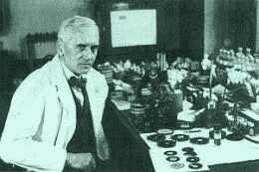
- How Penicillin Was Discovered

In 1928, Sir Alexander Fleming was studying Staphylococcus bacteria growing in culture dishes. He noticed that a mold called Penicillium was also growing in some of the dishes. A clear area existed around the mold because all the bacteria that had grown in this area had died. In the culture dishes without the mold, no clear area.
Fleming hypothesized that the mold must be producing a chemical that killed the bacteria. He decided to isolate this substance and test it to see if it would kill bacteria. Fleming transferred the mold to a nutrient broth solution. This solution contained all the materials the mold needed to grow. After the mold grew, he removed it from the nutrient broth. Fleming then added the nutrient broth in which the mold had grown to a culture of bacteria. He observed that the bacteria died which was later used to develop antibiotics used to treat a variety of diseases.
- Cad a thug Fleming faoi ndeara?

- Céard é an hipitéis a rinne sé?

- Cad a rinne sé chun an hipiteis seo a tástáil?

- I ndiadh na turgnaimh, an cóir go mbeadh an hipitéis glactadh nó diútaithe?

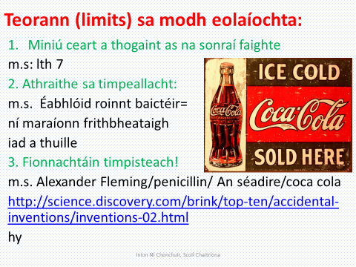

- Déan cuir síos (i do fhocail fhéin) ar tabhacht fhionnachtain (discovery) na peinicilline i gcursaí leighis.

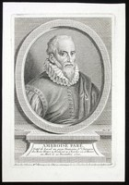
(c) Famous doctors: Ignaz Semmelweis
Ignaz Semmelweis was a Hungarian physician who paved the way for the discovery of germs when he found a cure for Puerperal fever. His discovery was so advanced it was widely unaccepted by the medical community. Read his amazing story below.

Why is he famous?
He became an assistant in the first obstetrical clinic of the Vienna General Hospital. He began investigating the causes of puerperal fever against the advice of his superiors who believed it to be non-preventable. Puerperal fever is a serious form of septicaemia (blood poisoning) contracted by women during or shortly after childbirth.
Maternal mortality due to puerperal fever was high and many women preferred to give birth on the street rather than being brought to the hospital.

An accidental discovery
In 1847, a friend of Semmelweis died from an infection contracted after his finger was accidentally punctured with a knife while performing a postmortem examination. The autopsy showed a pathological situation similar to that of the women who were dying from puerperal fever.
Semmelweis immediately proposed a connection between cadaveric contamination and puerperal fever and made a detailed study of the mortality statistics of the obstetrical clinic. He concluded that he and the students carried the infecting particles on their hands from the autopsy room to the patients they examined in the obstetrical clinic.

How clean hands saved lives
The germ theory of disease had not yet been developed at the time so Semmelweis concluded that some unknown "cadaveric material" caused childbed fever. He instituted a policy of using a solution of chlorinated lime for washing hands between autopsy work and the examination of patients. In April 1847 the mortality rate was 18.3 percent.
Hand-washing was instituted mid-May, the rates in June were 2.2 percent, July 1.2 percent.

